**Project Proposal: Covid-19 Exercise Application**

**What is the problem and who are the targeted users?**

Covid-19 has forced gyms and fitness centres to close their doors in order to comply with mandated public health orders. This has left many individuals looking for other ways to stay active at home or outdoors in order to maintain their health and fitness. The purpose of the application being proposed is to aid people with an alternative. Moreover, health and wellness applications have immensely gained popularity during these times, further proving such an application is desired by the target audience which is frequent gym users.

**What does the application do?**

We are proposing a health and fitness application that will offer tailored workout routines that users can conduct at home or outdoors without the need of a gym or expensive equipment. The application will also possess the ability to track the user’s exercise activity through a journal. Additionally, users will be able to search and filter through an extensive routine and video tutorial libraries to find and learn new exercises. Further capabilities include being able to set workout reminders to stay on track and also view a map of nearby locations such as public parks, track fields, or hiking trails where users can safely conduct workouts outdoors while following social distancing guidelines.

***Application Features & Capabilities:***

* Suggestions (Home Screen)
* Workout Routine Library
* Video Tutorial Library
* Activity Journal
* Reminders
* Nearby Workout Locations Map
* Rating System

**How does the application suggest/filter workouts and exercises?**

Upon registering for the application, users will be able to input their personal information and answer a series of questions from which personalized workout plans and exercises will be suggested to them according to their respective needs and goals. This data can always be adjusted in account settings if things change. Additionally, when users are trying to find general workout routines or using the video tutorial library to find new exercises, they will be able to filter them by type, muscle group, difficulty, duration, and available equipment. Routines can be geared towards a variety of training categories such as strength, endurance, agility, balance or a combination. Workout exercises will be able to be conducted without expensive gym equipment and instead use common workout items users may already own or items they can use in their place such as everyday household items. These exercises may not require any equipment or make use of low-cost items such as free-weights, resistance bands, medicine balls, and more. There will be a wide variety of exercises and even circuit/drill training options. If a user is uncomfortable or does not prefer a particular exercise, they possess the ability to omit it and have the application offer them a substitute. The rating system will enable users to do this by letting them rate the effectiveness of workouts and individual exercises which will allow the application to recommend them again in future routines and avoid ones that are not preferred.

**How will the application know what equipment is available to the user?**

If a user does not have a particular exercise’s specified equipment available, the application will adjust their workout plan to accommodate it. Everyday household items will also be offered as alternatives. For example, dumbbells can be replaced with water jugs or resistance bands can be replaced with bungee cords. When a user clicks on an exercise, it will show them these options. Options will include using a common everyday item in its place or replacing it with an exercise that uses equipment they do have. The application will also keep track of this activity to continuously improve workout routine suggestions.

**How will the application layout look and function?**

The application’s aim is to offer a visually appealing and friendly user-experience. The design will be geared towards smartphone users as it is the device they will most likely be using while working out. The main home screen will display daily suggestions on workout routines the user may want to partake in that day. Additionally, a small widget showing upcoming reminders and journal entries from the past few days will also be shown for quick reference. The navigation menu is where the user will be able to access the other aspects of the application. There will be separate screens for the workout routine library, tutorial library, journaling, reminders, and nearby workout location map. Both the workout routine and tutorial library will feature an extensive filtering option to narrow down search results. There will be a seperate section where users can adjust application and account settings. When a user initiates a workout routine, they will be taken to a separate screen which will show them a list of exercises to perform with a set duration and reps/sets. Each exercise can be clicked to view a video tutorial and rated to indicate if the user likes it or wants a substitute. Alternative equipment options will also be shown in this area.

*(Sketches can be seen on the following page.)*

**Sketches**

***Home Screen***

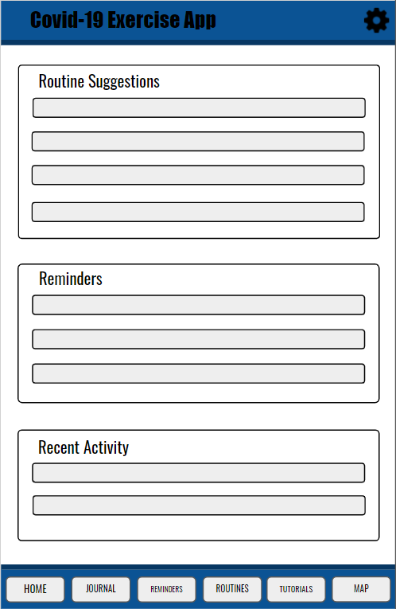

***Routine Screen***

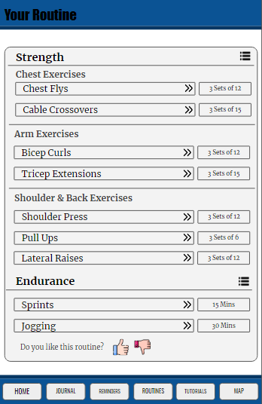

***Exercise Screen***

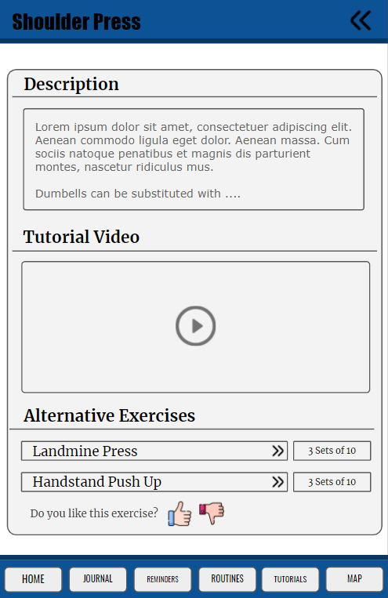

**Survey Questions**

1. *How well does the application address the problem of closed down gyms?* (Rate)
2. *How often would you use this application as an alternative to working out in a gym?* (Rate)
3. *Do you believe the application is missing any features that should be included?* (Open)
4. *What feature are you most likely to use?* (Multiple Choice)
5. *What feature are you least likely to use?* (Multiple Choice)